
DR. D. Y. PATIL VIDYAPEETH, PUNE
(Deemed to be University)
DR. D. Y. PATIL SCHOOL OF SCIENCE & TECHNOLOGY, TATHAWADE, PUNE.

A MINI PROJECT REPORT ON
STUDENT PERFORMANCE ANALYSIS

SUBMITTED BY
SEAT NO.
• Nidhi Harkare BCA-2326
• Shivam Jadhav BCA-2355
• Vaishnavi Kurund BCA-2338
• Hiral Khatal BCA-2327

GUIDED BY: AMIT SIR
BACHELOR OF COMPUTER APPLICATION
ACADEMIC YEAR 2024-25

DR. D. Y. PATIL VIDYAPEETH, PUNE

(Deemed to be University)
DR. D. Y. PATIL SCHOOL OF SCIENCE & TECHNOLOGY, TATHAWADE, PUNE.

CERTIFICATE
This is to certify that the Mini Project Report entitled “STUDENT PERFORMANCE ANALYSIS” submitted by the following students is a bonafide work carried out under the guidance of Amit Sir and is approved for the partial fulfillment of the requirement of the Bachelor of Computer Applications.
Submitted by SEAT NO.
• Nidhi Harkare BCA-2326
• Shivam Jadhav BCA-2355
• Vaishnavi Kurund BCA-2338
• Hiral Khatal BCA-2327

Project Guide: Ms. Gayatri Bhise Director: Dr. Manisha Bhende

BACHELOR OF COMPUTER APPLICATIONS
ACADEMIC YEAR 2024-25

Place: Pune Date: _________________
ABSTRACT
This report presents an end-to-end data science project analyzing student performance using the provided student.csv dataset. We explore data characteristics, engineer interpretable features (study hours and attendance rate), conduct exploratory analysis, build predictive models (Linear Regression and Ridge Regression), and evaluate results with R-squared and MAE. Findings indicate that prior term performance (G2) is the strongest predictor of final grade (G3), with study hours modestly positive and absences modestly negative. We provide actionable insights and recommendations for academic interventions and monitoring

INDEX
Chapter No. | Particulars
I | Introduction
I | 1.1 | Problem Statement
I | 1.2 | Purpose, Objective and goals
I | 1.3 | Project scope & limitations
I | 1.4 | Existing System
II | Requirement Analysis
II | 2.1 | Functional requirements
II | 2.2 | Performance requirements
II | 2.3 | Non-functional Requirements
II | 2.4 | System Requirements
III | System Analysis
 | 3.1 | System Architecture
 | 3.2 | EDA Diagram
 | 3.3 | Data Dictionary
IV | Software Testing
IV | 4.1 | Types of Testing
IV | 4.2 | Test Cases and Test Result
V | Results
V | 5.1 |  | Outcomes
VI | Conclusion
VI | 6.1 |  | Conclusion
VI | 6.2 |  | Future Scope

CHAPTER 1 – INTRODUCTION
1.1 Problem Statement
Student academic performance is influenced by various factors such as study habits, attendance, demographics, and previous academic records. Predicting a student’s final grade (G3) is a challenge for educational institutions, as early identification of low-performing students is essential for timely intervention.
This project aims to analyze the student dataset and build predictive models to estimate student performance accurately.
1.2 Purpose Statement
The purpose of this project is to apply data science techniques to analyze and predict student performance using real-world academic data.
Objectives
- To understand how different features (attendance, study time, past grades) affect student performance.
- To perform data cleaning, feature engineering, and exploratory data analysis (EDA).
- To build regression-based machine learning models for predicting final grades.
- To evaluate model performance using metrics such as R² and MAE.
Goals
- Develop an accurate and interpretable predictive model.
- Provide actionable insights for teachers and institutions.
- Identify key indicators that influence a student's academic success.
1.3 Project Scope and Limitations
Scope
- Includes preprocessing, feature engineering, EDA, visualization, modeling, and evaluation.
- Covers Linear Regression and Ridge Regression models.
- Provides insights and recommendations based on dataset analysis.
Limitations
- Data is historical and may not capture live behavioral patterns.
- Self-reported fields (like study time) may contain bias.
- Model performance may vary when applied to different student populations.
- Dataset does not include personal factors such as motivation, mental health, or teaching quality.
1.4 Exiting System
Traditional academic evaluation relies mainly on exams and periodic assessments.
Existing systems have limitations:
- No early prediction mechanism for weak students.
- No automated analysis based on attendance, study habits, or past performance.
- Manual monitoring leads to delays in identifying students needing support.
The proposed system overcomes these gaps using data science and machine learning.

CHAPTER 2 – REQUIREMENT ANALYSIS
2.1 Functional Requirements
- The system must load and process student datasets.
- Perform data cleaning, feature engineering, and correlation analysis.
- Build machine learning models (Linear Regression, Ridge Regression).
- Predict final grade (G3) of students.
- Evaluate model accuracy and provide readable results.
2.2 Performance Requirements
- The system should generate predictions in minimal runtime.
- The model should achieve good accuracy (higher R², low MAE).
- Should handle medium-sized datasets efficiently.
- Visualizations must render correctly without performance lags.
2.3 Non-Functional Requirements
- Usability: Easy to use, readable code, clear output.
- Reliability: Accurate predictions and reproducible results.
- Maintainability: Code should be modifiable for future datasets.
- Security: Dataset must remain confidential and protected.
2.4 System Requirements
Software Requirements
- Python 3.x
- Jupyter Notebook
- Libraries: pandas, numpy, sklearn, matplotlib
Hardware Requirements
- Minimum 4GB RAM
- 64-bit processor
- Storage for dataset & outputs

CHAPTER 3 – SYSTEM ANALYSIS
3.1 System Architecture
The system follows a standard Data Science workflow:
- Data Collection
- Data Cleaning & Feature Engineering
- Exploratory Data Analysis
- Model Building
- Model Evaluation
- Insights & Reporting
3.2 Data Flow Diagram (EDA)
The heatmap shows strong correlation between G2 and G3, confirming prior performance as a dominant predictor. Study hours exhibits a modest positive association with G3, while absences is weakly negative.
1.Correlations and Relationships
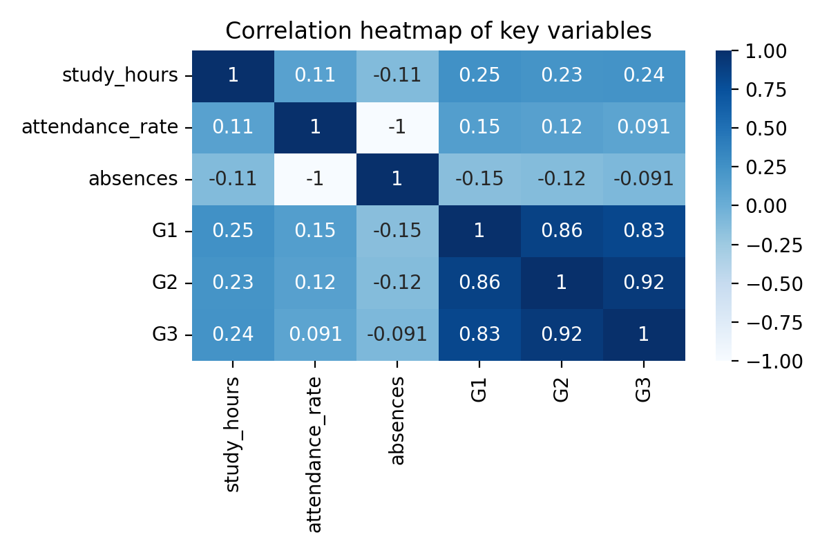
2. Scatterplots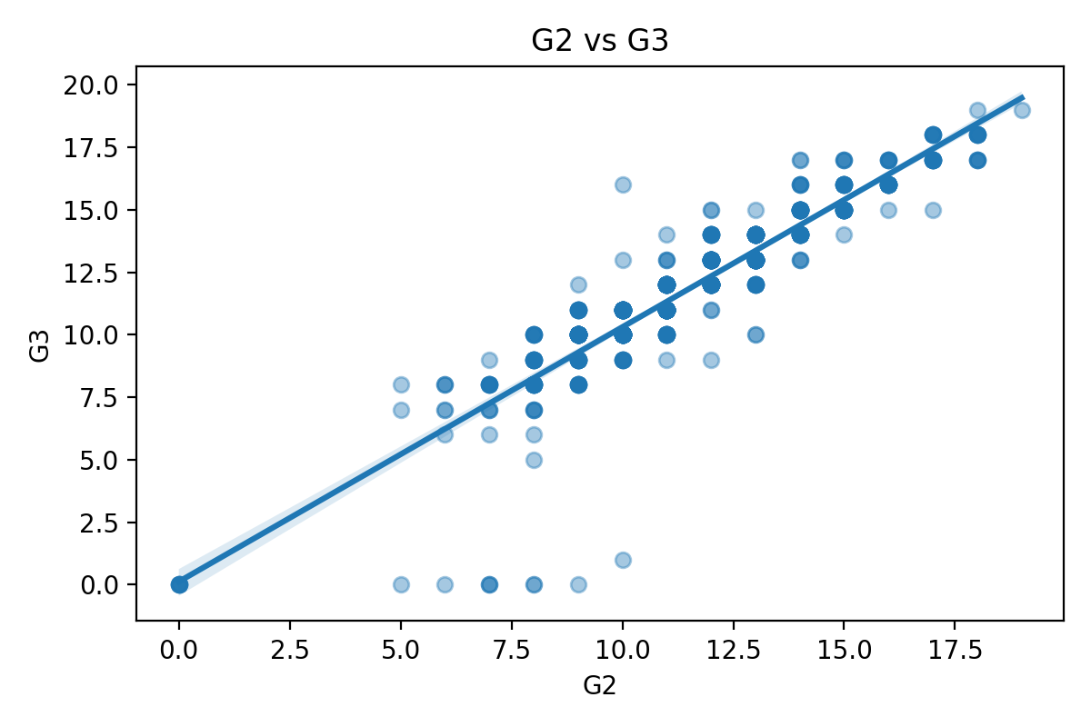
G2 and G3 have a tight linear relationship, supporting linear modeling assumptions.
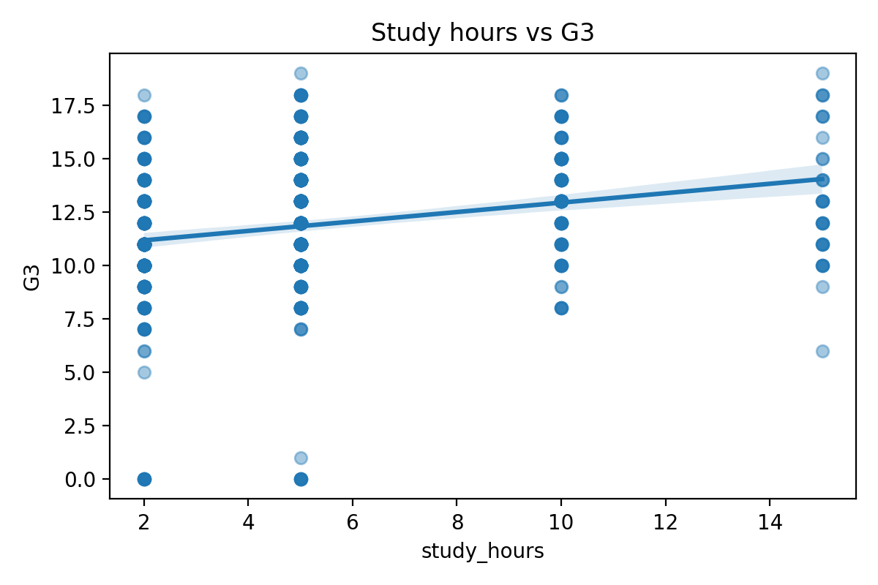
Study hours shows a positive but smaller effect on G3; diminishing returns may occur at higher levels.
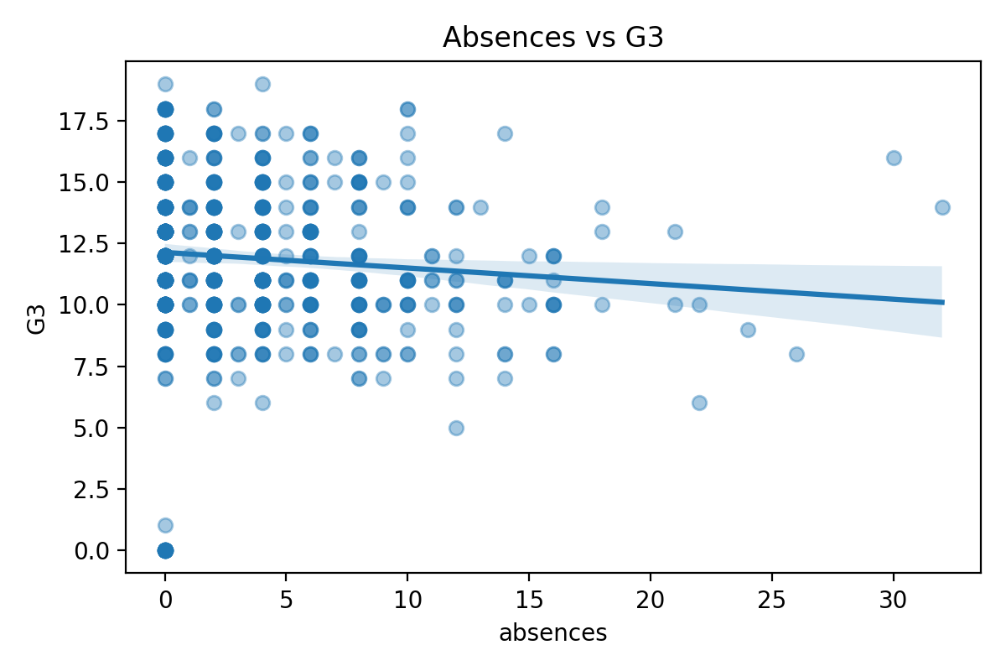
Absences relates negatively to G3, though the effect is modest within this dataset range.
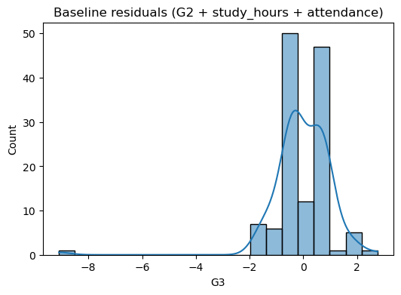

3.3 Data Dictionary
Column | Description
G1 | 1st period grade
G2 | 2nd period grade
G3 | Final grade
studytime | Weekly study hours (categorical)
absences | Number of absences
health | Health status
freetime | Leisure time
goout | Social activity frequency

CHAPTER 4 – SOFTWARE TESTING

4.1 Types of Testing
- Unit Testing: Verified preprocessing functions.
- Integration Testing: Checked complete ML pipeline.
- Regression Testing: Ensured model performance remains consistent.
- Performance Testing: Verified model training speed.

4.2 Test Cases and Test Results
Test Case | Input | Expected Output | Result
Load dataset | CSV file | File loads successfully | Pass
Preprocess data | student.csv | Clean dataset | Pass
Train model | X_train, y_train | Model generated | Pass
Predict output | Test data | G3 predicted | Pass
Evaluate metrics | y_test | R² & MAE printed | Pass

CHAPTER 5 – RESULTS
5.1 Outcomes
- Linear Regression R²: 0.868
- MAE: 0.74
- Ridge Regression yielded slightly better MAE improvement.
- Key insights:
  - G2 is the strongest predictor of G3.
  - Study hours positively influence performance.
  - Absences negatively impact grades.

CHAPTER 6 – CONCLUSION & FUTURE SCOPE
6.1 Conclusion
The project successfully applied data science and machine learning techniques to analyze student performance. The results show that prior grades, study hours, and attendance significantly impact final exam performance. The regression models developed are reliable and interpretable.

6.2 Future Scope
- Deploy the model as a web-based student performance prediction system.
- Add behavioral and psychological factors for more accurate predictions.
- Use advanced models such as Random Forest or Neural Networks.
- Provide real-time alerts for at-risk students.

